ROUNDSWELL COMMUNITY PRIMARY ACADEMY

MOBILE PHONE POLICY

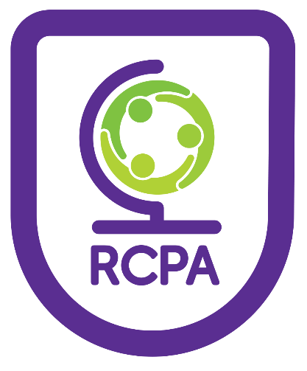

Date Adopted: September 2022
Anticipated Review: September 2023

Mobile Phone Policy

Introduction and Aims
At Roundswell Community Primary Academy the welfare and well-being of our pupils is paramount. The aim of the Mobile Phone Policy is to allow users to benefit from modern communication technologies, whilst promoting safe and appropriate practice through establishing clear and robust acceptable mobile user guidelines. This is achieved through balancing protection against potential misuse with the recognition that mobile phones are effective communication tools. It is recognised that it is the enhanced functions of many mobile phones that cause the most concern, offering distractions and disruption to the working day, and which are most susceptible to misuse - including the taking and distribution of indecent images, exploitation and bullying. However as it is difficult to detect specific usage, this policy refers to ALL mobile communication devices.

Scope
This policy applies to all individuals who have access to personal mobile phones on site. This includes staff, volunteers, committee members, children, young people, parents, carers, visitors and contractors. This list is not exhaustive.
This policy should also be read in relation to the following documentation:
- Safeguarding Policy
- Anti-Bullying Policy

Code of conduct
A code of conduct is promoted with the aim of creating a cooperative workforce, where staff work as a team, have high values and respect each other; thus creating a strong morale and sense of commitment leading to increased productivity.
Our aim is therefore that all practitioners:
• have a clear understanding of what constitutes misuse.
• know how to minimise risk.
• avoid putting themselves into compromising situations which could be
misinterpreted and lead to possible allegations.
• understand the need for professional boundaries and clear guidance regarding
acceptable use.
• are responsible for self-moderation of their own behaviours.
• are aware of the importance of reporting concerns promptly.
It is fully recognised that imposing rigid regulations on the actions of others can be counterproductive. An agreement of trust is therefore promoted regarding the carrying and use of mobile phones within the setting, which is agreed to by all users:

Personal Mobiles - Staff
- Staff are not permitted to make/receive calls/texts during contact time with children. Emergency contact should be made via the school office.
- Staff should have their phones on silent or switched off and out of sight (e.g. in a drawer, or bag) during class time
- Mobile phones should not be used in a space where children are present (eg. classroom, playground)
- Use of phones (inc. receiving/sending texts and emails) should be limited to non-contact time when no children are present and may only be used in the offices, meeting room or staff room.
- It is also advised that staff security protect access to functions of their phone.
- Staff are not at any time permitted to use recording equipment on their mobile phones, for example: to take recordings of children or sharing images. Legitimate recordings and photographs should be captured using school equipment such as school ipads or Gos.
- Staff should report any usage of mobile devices that causes them concern to the Headteacher or Deputy Headteacher.

Mobile Phones for work related purposes
We recognise that mobile phones provide a useful means of communication on offsite activities. However staff should ensure that:
- Mobile use on these occasions is appropriate and professional (and will never include taking photographs of children).
- Mobile phones should not be used to make contact with parents during school trips – all relevant communications should be made via the school office. The exception to this will be during an emergency or whilst on residential.
- Where parents are accompanying trips they are informed not to make contact with other parents (via calls, text, email or social networking) during the trip or use their phone to take photographs of children.

Personal Mobiles - Pupils
We recognise that mobile phones are part of everyday life for many children and that they can play an important role in helping pupils to feel safe and secure. However we also recognise that they can prove a distraction in school and can provide a means of bullying or intimidating others. Therefore:
- Pupils are not permitted to have mobile phones at school or on trip
- If in the rare event of a parent wishing for his/her child to bring a mobile phone to school to contact the parent after school:
- the parent must discuss the issue first with their child’s teacher.
- the phone must be handed in, switched off, to the teacher first thing in
the morning and collected from them by the child at home time (the phone is left at the owner’s own risk).

- Mobile phones brought to school without permission will be confiscated and returned at the end of the day.

Where mobile phones are used in or out of school to bully or intimidate others, then the Head teacher & Deputy Headteacher do have the power to intervene ‘to such an extent as it is reasonable to regulate the behaviour of pupils when they are off the school site’ - refer to Anti-Bullying Policy.

Volunteers, Visitors, Representatives and Contractors
All Volunteers, Visitors, Representatives and Contractors are expected to follow our mobile phone policy as it relates to staff whilst on the premises.
On arrival, such visitors will be informed of our expectations around the use of mobile phones.

Parents
While we would prefer parents not to use their mobile phones while at school, we recognise that this would be impossible to regulate and that many parents see their phones as essential means of communication at all times.
We therefore ask that parents’ usage of mobile phones, whilst on the school site is courteous and appropriate to the school environment.
We also allow parents to photograph school events such as sports day using their mobile phones – but insist that parents do not publish images (e.g. on social networking sites) that include any children other than their own.

Dissemination
The mobile phone policy will be shared with staff and volunteers as part of their induction. It will also be available to parents via the school office and website.

Date Agreed: October 2022

Date for review: October 2024

